|  |
| --- |
| ANDROID PENETRATION TESTING WITH MOBSF |
| SAAD USMAN |
| BCSP243016 |

|  |
| --- |
| ztech  [Pick the date] |

Step 1:

This command updates the package list and upgrades all installed packages to their latest versions — best practice before any installation. Sudo apt update && sudo apt upgrade-y

STEP 2:

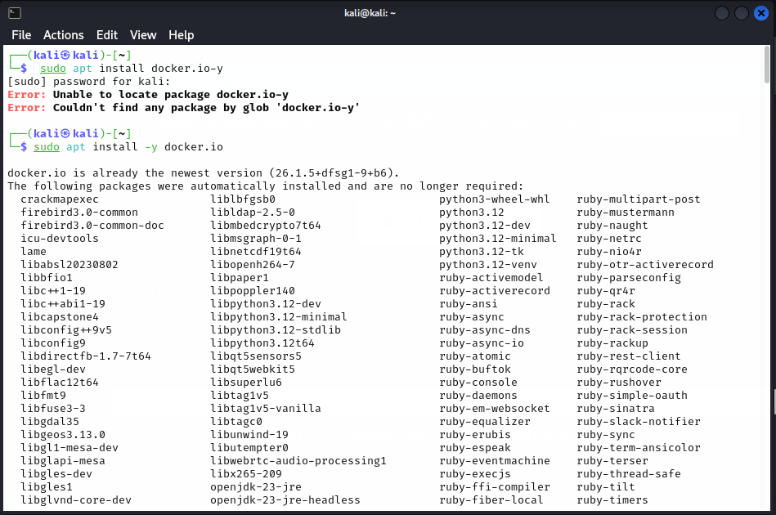

STEP 3:

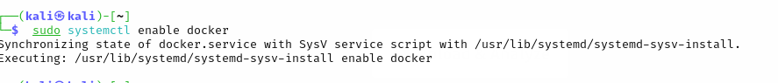

STEP 4:



STEP 5:

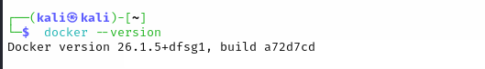

STEP 6:

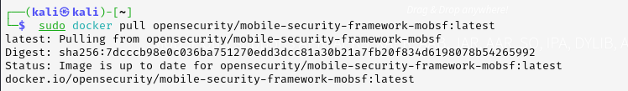

STEP 7:

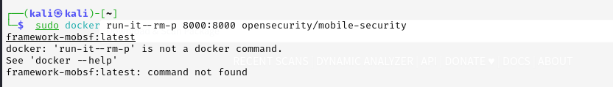

STEP 8:

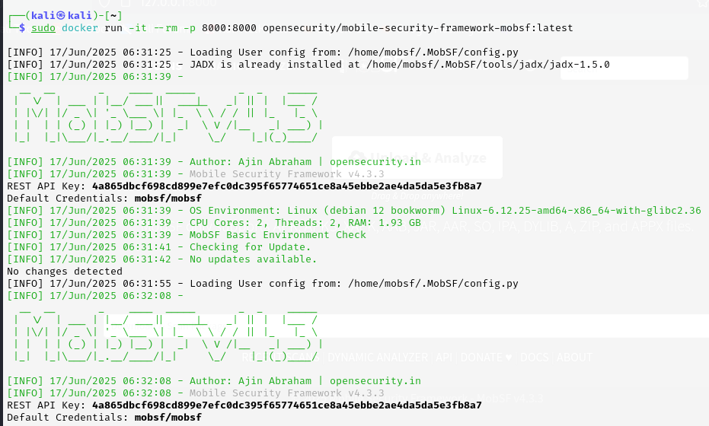

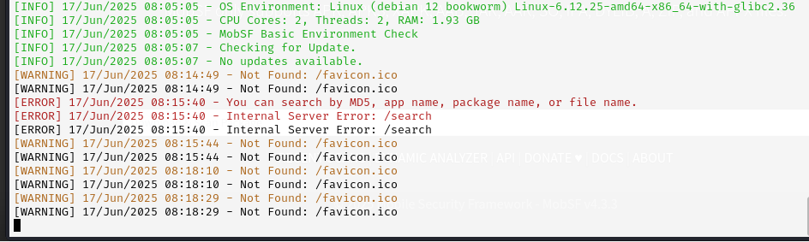

Yahan tak karnay kay bad is ko isi tarhan run honay dain or apnay (kali linux) kay browser par ah jain .

Phir wahan yeh command run karain :

**In browser:**

http://127.0.0.1:8000/

STEP 9:

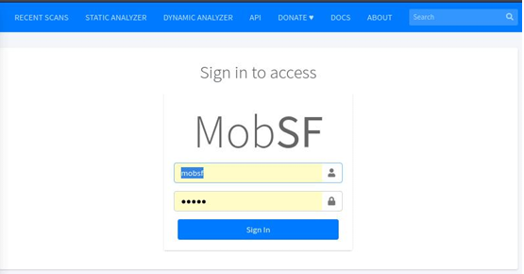

**Username:** mobsf

**Password:** mobsf

**STEP 10:**

phir hum koi bhi apk ki file utha kar yahan par rakh dain gaye. Or phir humaray samnay data show hoo ga.

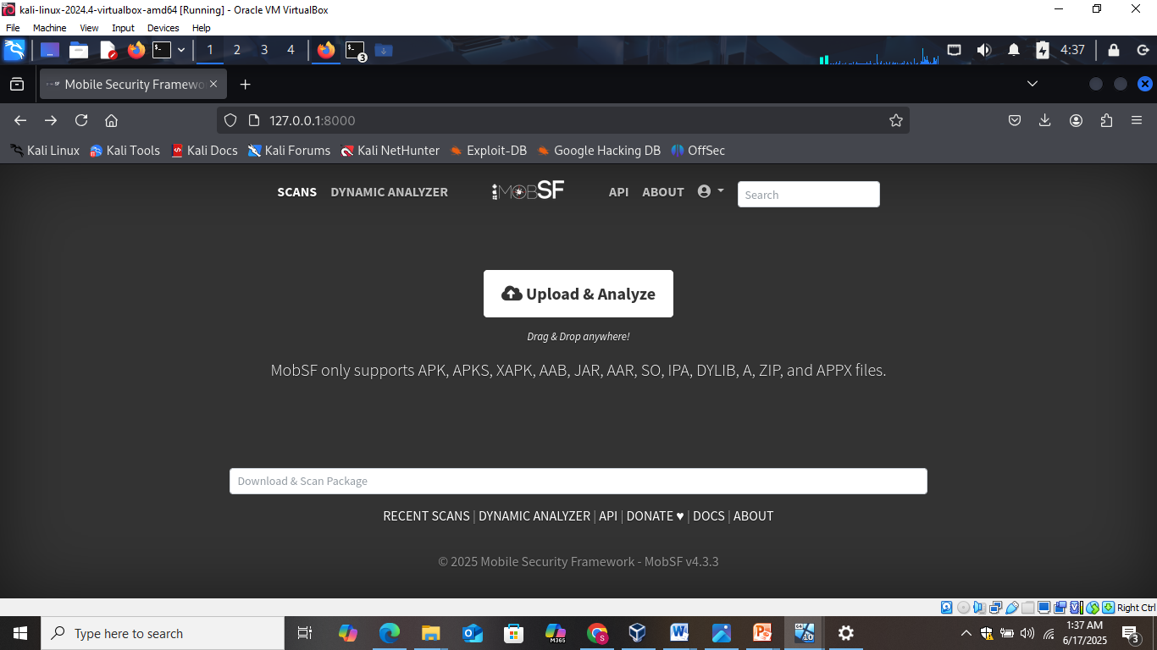



Step 11:

Phir is( <https://apkpure.com/whatsapp-android/com.whatsapp/download> ) link par jain or yahan se apk files uthain or unhay choose karain .

